**Homework Assignment #2, Math 740/840, Fall 2019**

**Due Friday 10/04/2019**

**Charlie Nitschelm**

1. (15 pts) A one factor experiment has been performed to study the effectiveness of three different drugs used to sedate deer for medical examination and tagging. There are three types of drugs used and 10 replicate deer for each drug. The response is knock down time (KD Time) measured from when the drug is injected to when the deer is fully sedated. Typically shorter times are preferred. Use the dataset **DeerSedation.JMP** to answer the following questions.   
     
   Problem 2 a) The EU is sample of water that is filtered d) Laboratory is a significant source of variation . The F ratio is 7.32 for Laboratory which is > 1 (Recall the p-value is not correct for blocking.
2. What is the EU? Is there subsampling in this experiment? Explain.  
   **The deer is the EU as it is getting the treatment of drugs. Because the data only includes two columns of data, there is no subsampling as there is just the drug used and the response.**
3. Perform a One-way ANOVA for an effect of Drug on knock down time (use Fit Y by X in JMP). Clearly state the null and alternative hypotheses. What is the p-value and your decision concerning the null hypothesis?  
   **The null hypothesis is that all the knockout mean times is the same, and the alternative hypothesis is that at least one of them are different then the others, meaning the drugs have different affects on the mean knockout time.**

**p-value=0.0102  
With this, we would reject the null hypothesis as the p value is lower than 0.05. One of the means show a significant difference!**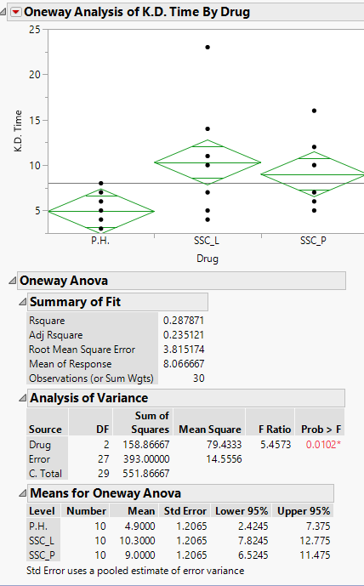

1. Perform the “Each Pair, Student’s t” means comparison procedure. Which drug or drugs appear different?   
   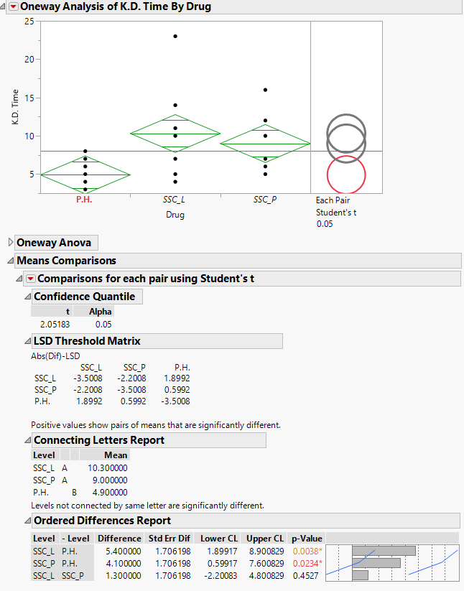

**From looking at the circles, it seems that the P.H. drug is significantly different from the other ones, and is also described below that with being on the B level.**

1. Perform Hsu’s MCB procedure. Does there appear to be a best level or levels of drug assuming a shorter time is best? Explain.  
   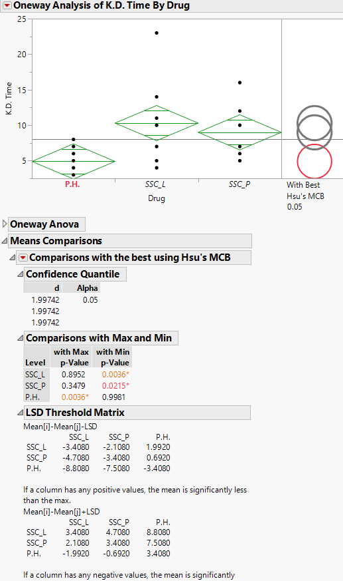  
   **From above, it is clear that the** **best drug is P.H. as it delivers the lowest time of Knockout. It is proven in the data by noticing that no other circles are a shade of red when clicked, meaning they are significantly different.**
2. Perform Tukey-Kramer HSD procedure. Which drugs appear different on average? Explain.  
   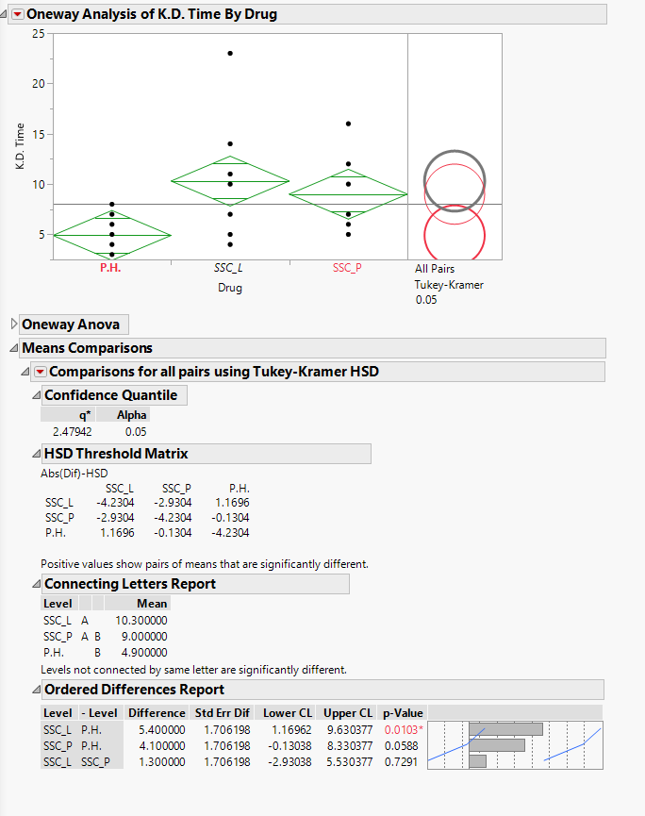

**The image above shows that there is only a significant difference between the P.H. drug and the SSC_L drug during this test. This is due to having only of the circles shade red when clicked on.**

1. Perform an Analysis of Means (ANOM). Describe what is specifically being tested in ANOM concerning the treatment means? What are your conclusions based on the ANOM?

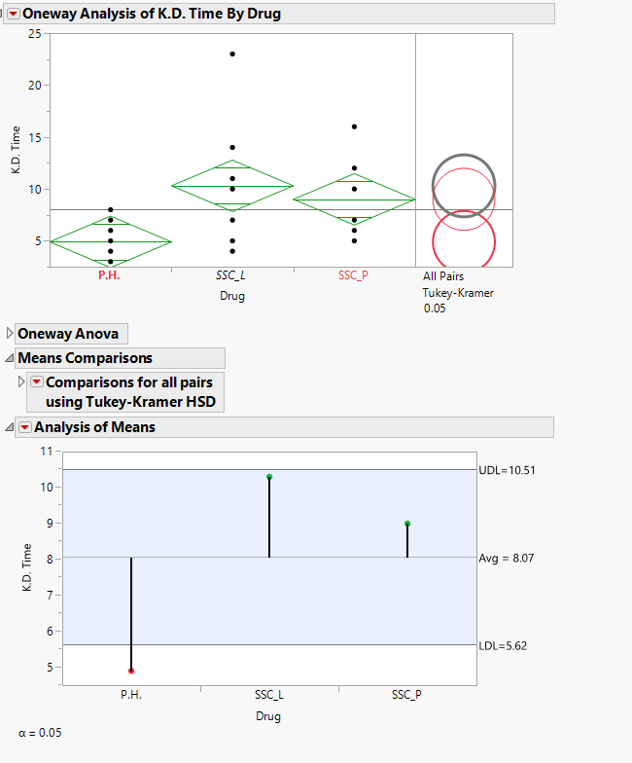  
  
**ANOM is a test that looks for a difference on the grand averages of means. So for the deer, a difference in the grand averages for the knock out times for deer. This yields the same results as the Student’s test from before, showing that the P.H. drug is significantly different then the other two drugs.**

1. (15 pts.) An experiment has been performed to study the difference in performance between four types of water **Filters** used to remove effluents from drinking water. The response is the amount of **removal** of effluents from a large sample of municipal water. All filtration trials used the same water source. The **laboratory** where the experiments are performed can only accommodate four samples, therefore in order to replicate the experiment the researchers had to use four different laboratories. It is suspected that differences in measured removal may exist between the laboratories, but the inter-laboratory differences are not of direct interest. Use the dataset **Water Filtration Dox.JMP** to answer the questions for this problem.  
   1. What is the EU?   
       **Sample of water that is filtered.**
   2. What type of factor is laboratory?  
      **It is a block factor!**
   3. Perform a one-way ANOVA for a Filter effect and clearly state your conclusions concerning the null hypothesis of no differences.  
      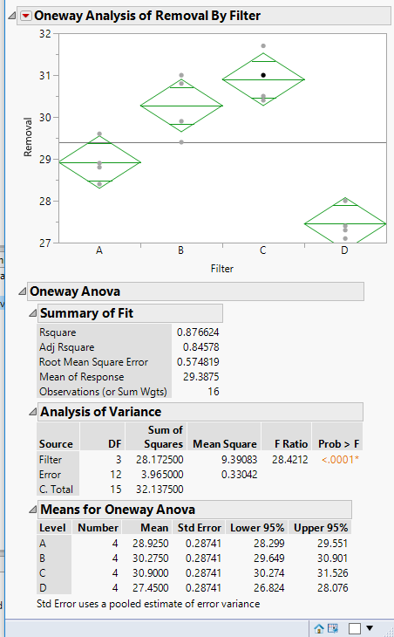  
      **The p-value is far below the 0.05 limit, which leads us to reject the null hypothesis in favor of the alternative hypothesis. This means that there is AT LEAST one significant difference in the filter used.**
   4. Based upon your ANOVA in part c does laboratory seem to contribute significant variation to the measured removal values? Explain the basis for your answer.  
      **The laboratory does offer a significant variation to the measured values. This is because the F ratio is greater then 1 (cant use p-value for blocking?)**
   5. The goal of the experiment is to find the Filtration method that yields the highest removal rate. Use an appropriate multiple comparison method to find the best Filter or Filters.  
      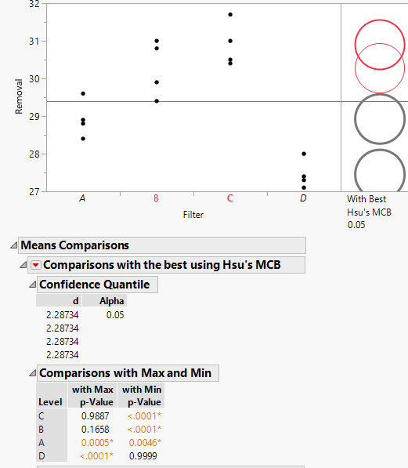  
      **The Hsu’s method shows that that highest rate of removal is C, and because there is another circle highlighted when selected, there is another method that is similar to it, but using the Max and Min comparisons, it is first on the list with a p-value of less then .0001 meaning we can conclude that it is still the best filter method.**
   6. It turns out that Filtration method D was a Control and no filtration was applied to the source water. Use an appropriate multiple comparison method to determine if any of the other Filtration methods were significantly higher in removal than the control? What are your conclusions?  
      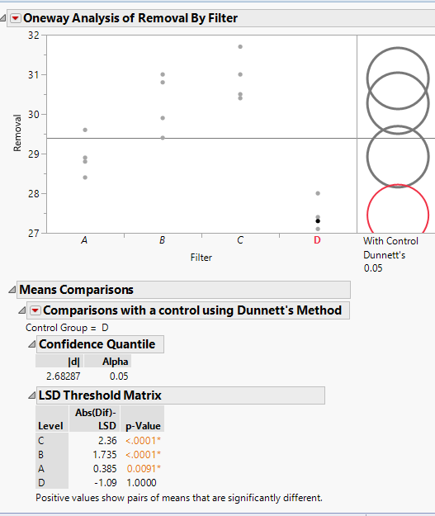  
      **Using Dunnet’s method, it is obvious that A, B and C filters are significantly different then the control, as it is the only circle that is highlighted in red when analyzed.**
2. (15 pts) The prothrombin time (PT) is the time (in seconds) it takes a blood plasma sample to clot after addition of a tissue factor. The PT is used to determine the clotting tendency of blood from a patient. The test is commonly given to patients on “blood thinners” such as Warfarin to measure the therapeutic effect of a given dosage. Because of natural variation in batches of tissue factor, the PT results are usually converted to an International Normalization Ratio or INR. An INR = 1 indicates a normal clotting time for a healthy individual not taking “blood thinners”. INR values in the range of 2.0 to 3.0 are generally considered desirable and therapeutic in preventing blood clots. Doctors consider an INR shift of 0.25 in a patient to be of clinical importance. In a particular MSA on a type of Pro-timer test, 3 operators performed INR measurements on 5 certified QA plasma samples, and each operator redid the test twice (2 repeat measurements). The data are in the file **INR MSA.JMP**. We will use the Variability Chart platform in JMP (**Analyze 🡪 Quality and Process 🡪 Variability/Attribute Gauge Chart**) to perform a measurement systems analysis (MSA) of the data.  
   1. (2 pts) In the Variability Chart launch dialog specify INR as the response **Y**, Operator as **X, Grouping**, QA Samples as **Parts, Sample ID**, and Certified INR as the **Standard**. In the Report Window select the Connect Cell Means and Show Group Means options from the main menu notes.  
        
      Comment on the Variability Chart at the top of the Report window. Does there appear to be significant operator to operator variability? Is there significant repeatability variation among the duplicate measurements taken by each operator on each sample? Do all operators seem to measure the 5 samples in the same way?  
      **There doesn’t appear to be significant variation between operator to operator. There also doesn’t appear to have a large repeatability variation, with a overall standard deviation of points of 0.131. For each sample measured by each operator, they seem to have consistent overall measurement values of each of the samples.**
   2. (3 pts) Select the Variance Components option from the main Report menu. Note, if you receive a Bayesian Variance Components report you can use that report or the more traditional report. Discuss the variance components report in terms of the measurement system. How much of the total variation is due to Operator? How much is due to Repeatability (within)? Do the operators seem consistent in how they measure each of the 5 samples (Operator*Sample variance)?
   3. (3 pts) Given we have certified values for each of the QA samples; it is possible to assess test accuracy or bias. From the Gage Studies submenu select Bias Report and comment on potential measurement bias for each of the 5 certified samples. Do you think the test is accurate enough across the range of INR values used in the study? Recall, doctors consider a deviation of 0.25 to be of clinical interest.
   4. (3 pts) From the Gage Studies submenu select Gage R&R to perform a traditional Gage R&R MSA. Use a Tolerance Interval of 0.5. From the R&R report comment on the relative contributions to measurement error of Operator, Operator*Sample, Repeatability. Which of these appears to be of most concern in terms of measurement error? Why?
   5. (2 pts) Based on the P/T ratio in the Gage R&R report do you think this particular Pro-timer test method is capable of distinguishing a shift of 0.25 (or tolerance of 0.5) in a patient’s INR level? Why or why not?
   6. (2 pts) Based upon the MSA you have just performed, do you think a doctor should adjust a “blood thinner” dosage if a shift of 0.25 (lower or higher) or so is observed in the patient’s latest INR test value? In other words, is this likely to be a true shift in INR or simply test noise? Explain.